For kind distribution to all those in prison by the IPS.


Jubilee of Prisoners
14th December 2025

“For everyone, may the Jubilee be a moment of genuine personal encounter with the Lord Jesus who is our hope.” - Pope Francis

Jubilee Years - also known as Holy Years - began in 1300 AD and occur every 25 years. Jubilee Years can be called at other times, such as the Year of Mercy in 2016. These years, the Church explains, are years “of reconciliation between adversaries, of conversion and receiving the Sacrament of Reconciliation, [...] and consequently of solidarity, hope, justice, commitment to serve God with joy and in peace with our brothers and sisters.”

The image of Christ crucified reminds us of God’s immeasurable mercy and love for each one of us, redeeming us from sin and winning for us eternal life and grace. The Cross serves as a symbol of Christ’s love and the hope that guides us.

In the shadow of the Cross, we are reminded of our shared journey of faith, unity and the call to live out Christ’s mission of hope and love. Therefore, the crucifix in each of our churches/chapels/oratories should be a focal point, a point of reference for our Jubilee pilgrimage or visit, inviting us to reflect on the significance of this special time of grace and renewal.

May this Jubilee of Prisoners be for each one of us a chance to grow in praise and thanksgiving to the God who loved us into existence and continues to pour out His graces upon us.

+ Martin Hayes
Bishop of Kilmore
Liaison Bishop to the Irish Prison Service
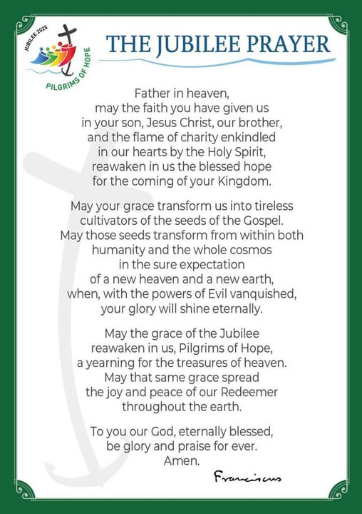


GUIDE TO CELEBRATING THE JUBILEE YEAR OF HOPE FOR THOSE IN PRISON,
14TH DECEMBER 2025

1. UNDERSTAND WHAT THE JUBILEE IS
The Jubilee Year of Hope is a gift of grace granted by the Church. It offers the opportunity to be forgiven of our sins and to offer forgiveness to others. You are invited to be:
- Truly repentant and free from attachment to sin,
- Purified through the Sacrament of Penance,
- Nourished by Holy Communion and
- To Pray for the Pope’s intentions.

2. THIS JUBILEE CELEBRATION IS AN OPPORTUNITY TO
- Go to Confession to be purified of your sins.
- Receive Holy Communion with reverence.
- Pray for the intentions of the Holy Father (these prayers may include one Our Father, one Hail Mary, and a Glory Be, but any prayer for the Pope’s intentions suffices).

3. YOU MAY CHOOSE TO FULFIL THE JUBILEE IN ANY OF THE FOLLOWING WAYS:

A. Make a Visit to the Prison Chapel
Participating in Holy Mass or other liturgical celebrations (e.g., the Rosary, or the Way of the Cross).
    - Spending time in Eucharistic Adoration and private prayer.
    - Include:
      - The Our Father.
      - Prayers to the Blessed Virgin Mary (e.g., Hail Mary).
      - The Glory be to the Father,…

B. Perform Works of Mercy or Penance
You may also participate in the Jubilee Year of Hope by acts of love and sacrifice, including such Corporal Works of Mercy as,
  - Visiting others in prison or assisting those in prison who are in need.
  - Dedicating time to volunteer work and/or such Spiritual Works of Mercy as:
    - Praying for the living and the dead.
    - Comforting the afflicted, forgiving offences, or patiently bearing wrongs.
and/or undertaking Friday Acts of Penance such as
      - Fasting, abstaining, or refraining from unnecessary distractions (e.g., reducing use of TV).
      - Offering donations or time to benefit others in need.

C. Participate in the Jubilee Year of Hope Without Travelling (for the Sick, Elderly, or Those Confined to Home, to their Prison Cell)
For those unable to leave their current place of residence:
  - Recite the Our Father, Hail Mary, Glory Be and prayers for the Holy Year (e.g., The Jubilee Prayer – see above)
  - Offer your sufferings or hardships in union with Christ.

