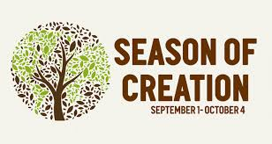

Suggested Practical Actions for Parishioners
during the Season of Creation 2020

Pope Francis has declared this year, 24th May 2020 – 24th My 2021,
a special Laudato Si’ Anniversary Year.

- Spend some time outside each day, in awareness, reconnect with nature.
- Start to grow some of your own food; support local producers.
- Compost your garden and food waste.
- Avoid or reduce the use of chemicals in your home and garden.
- Use (vinegar, baking soda) and buy eco- friendly cleaners. See (www.ecoverdirect.com)
- Plant pollinator friendly plants in your window box or garden at home and in your parish grounds. www.biodiversityireland.ie
- Check out the Faith Community Pollinator plan and think about how you could implement this in your church grounds https://pollinators.ie/communities/faith-communities/
- Shop wisely. Buy Fairtrade and buy locally made products when possible.
- Avoid waste. Reduce, reuse, recycle, recover, treat.
- Learn how to read your energy bills and make your home more energy efficient.
- Explore the use of renewable energy in your home, business and school, parish buildings (www.seai.ie).
- Participate in the Think Before You Flush campaign (www.thinkbeforeyouflush.org) and display the ‘Dirty Dozen’ posters in toilets in your parish buildings.
- Consider installing water butts in your gardens.
- Pray in and with nature – Encourage Laudato Si’ themed gardens in your parish.
- Volunteer your time in some creative project. Join an existing group.
- Offer a welcome to newcomers where you live.
- Explore Trōcaire’s 100 ways for Parishes to implement Laudato Si’ (https://www.trocaire.org/sites/default/files/pdfs/parishes/100-ways-to-implement-laudato-si.pdf)
- Become an Eco – Parish. See www.ecocongregationireland.com
- Take the Laudato Si’ Pledge (www.CatholicClimateMovement.global/petition )
- Discuss with / write to your local TD to express your concern on Ireland’s record on addressing the climate crisis. Check out www.onefuture.ie for some ideas.
- Can we help to conserve and protect water in our area? Water is the source of life for all living things. Can we restore a local Holy Well? Take a pilgrimage to a local Holy Well. See www.lovingsisterearth.com
- Get in touch with local Environmental Action Groups and/or organisations such as Trocaire, World Health Organization, Medecin sans Frontieres, etc.
- Can we spread hope across the world by twinning with a village in a drought-stricken area?

PLASTIC

- Refuse single use plastics such as cling film, straws, plastic cutlery.
- Switch to a reusable water bottle /travel cup.
- Use cloth bags for shopping; Bring/Use your own containers when possible.
- Check for and then avoid microbeads in products.
- Refuse packaging – Avoid - Reduce - Re-use – Recycle - Upcycle
- Check the new recycling list www.recyclinglistireland.ie
- Organise a recycling workshop in your parish/community www.voiceireland.org
- Show a film or documentary on the topic in your parish/community
- Participate in a beach, stream, river, park, street, area, road clean-up.

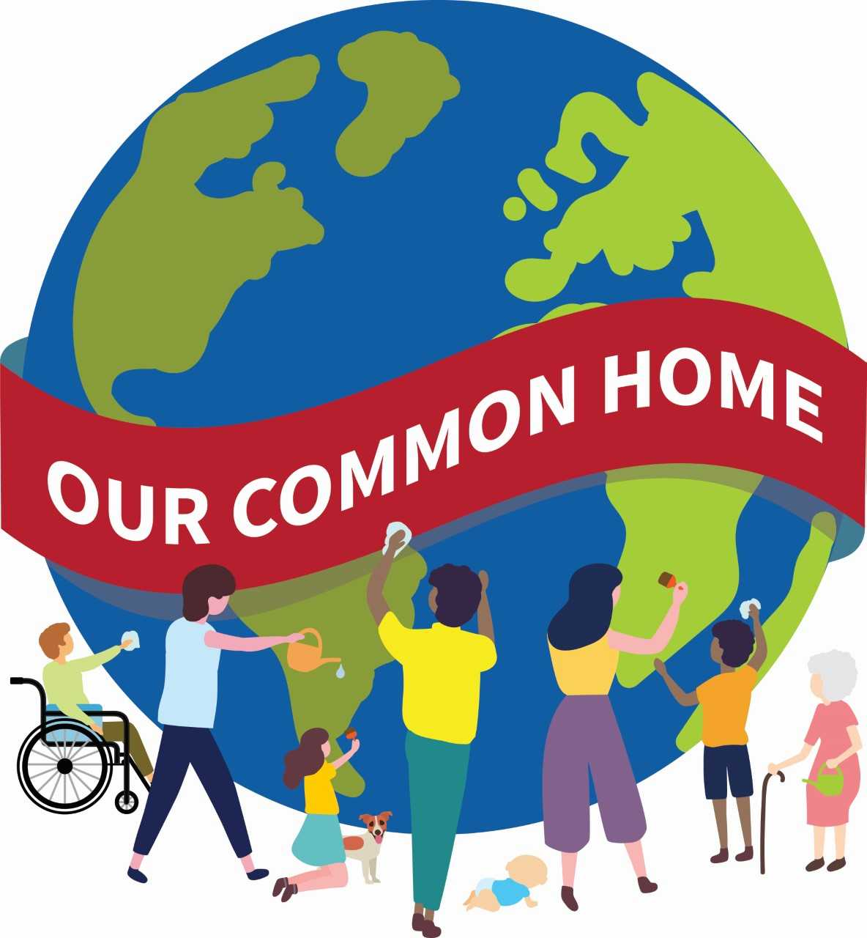

“Truly much can be done!” (LS, 180)

