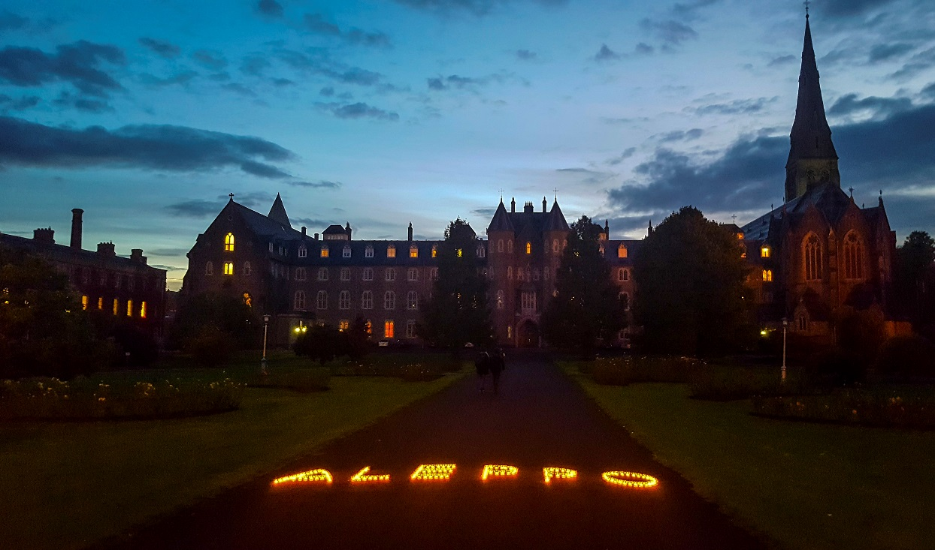
Trócaire candle lit vigil 17th October 2016. Photo Claire McEvoy

We present here a liturgy or prayer service for the parish that can be adapted for use in the classroom or for any group or family who wishes to pray together for an end to the war and violence in Syria.

Greeting and Introduction:
(Priest/Deacon/Leader (from now on referred to as the Presider): In the Name of the Father, and of the Son and Of the Holy Spirit
All: Amen
Presider: Peace be with you
All: And with your spirit.
Presider: We gather today in solidarity with the people of Aleppo, Syria in their ongoing suffering.
We ask the Lord to open our hearts and minds to the images we have seen on television and in the media.
As followers of Christ, we are called to be beacons of hope in the world. We must take action and be a light for the people of Aleppo.

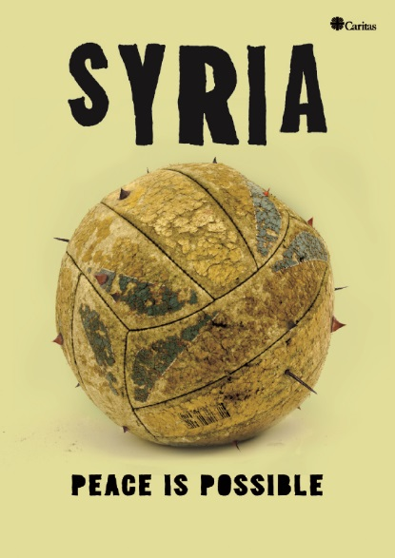
Reader 1: Syria has been ravaged by a brutal civil war since March 2011. The conflict has created a vast humanitarian crisis and continues to destroy people’s lives on a daily basis.
The war has knocked on every door in Syria, entered every house, and left behind its traces everywhere, and in every heart. Almost 13.5 million people in Syria are in need of assistance. 6.5 million people have been displaced within their own country and nearly 4.8 million people have been forced to flee to neighbouring countries to seek refuge. More than 230,000 people have been killed and thousands of others have been injured in the five-year conflict.
These numbers are not just statistics. These numbers represent men, women and children. These numbers represent our brothers and sisters in Christ.
Trócaire is responding to the crisis through the Caritas network; a global network of agencies who respond collectively to humanitarian situations in order to maximise impact. Pope Francis has called for an end to the fighting and has highlighted the assistance Caritas agencies including Trócaire, have provided to the Syrian people regardless of their ethnic or religious background. Trócaire has been working with Church and local civil society groups to support people in need with a focus on food and shelter in Aleppo, Damascus, Daraa city and surrounding villages. Through these partners, we are able to access people in government and non-government controlled areas, including people living under siege conditions. We are also providing psychological support to ensure people's safety and dignity.
We in (Parish/Community name) join with Pope Francis in saying:

"You are not alone ….Do not lose hope."
Pope Francis, to Syrian refugees on the Greek island of Lesbos, 16th April 2016
Liturgy of The Word

Presider: Gospel: Luke 18:35-43 NIV
As Jesus approached Jericho, a blind man was sitting by the roadside begging. When he heard the crowd going by, he asked what was happening. They told him, “Jesus of Nazareth is passing by.” He called out, “Jesus, Son of David, have mercy on me!” Those who led the way rebuked him and told him to be quiet, but he shouted all the more, “Son of David, have mercy on me!” Jesus stopped and ordered the man to be brought to him. When he came near, Jesus asked him, “What do you want me to do for you?” “Lord, I want to see,” he replied. Jesus said to him, “Receive your sight; your faith has healed you.” Immediately he received his sight and followed Jesus, praising God. When all the people saw it, they also praised God.

Reflection
Let us reflect on the hope in this Gospel story. Without hope, Syrians struggle to survive day to day, struggle to draw on their own natural resilience in the face of adversity. Part of that hope comes from knowing that ordinary people in the world outside Syria care about their plight, that they are not forgotten or abandoned. The blind man calls out to the Lord and despite the passers-by attempts to silence him, the Lord hears him and heals him. Jesus leads him out of the darkness and into the light. We here in (Parish/Community) will not be silent and we call for an end to the besiegement of Aleppo. We will be people of mercy today as we stand with the people of Aleppo. We believe peace is possible if we take action now.

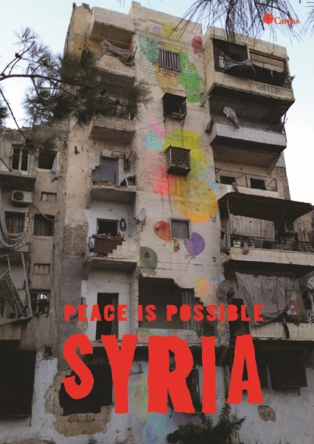
Reader 2:
‘The only time we socialise now is at funerals’
A member of Caritas Syria Central Committee talks about life in the western part of Aleppo city.
“Everyone is tired. There is no electricity, no running water. Everyone has back ache from dragging containers of water up many flights of stairs. Old wells are being re-opened, the water untreated, waterborne diseases are a problem. Babies are buried under piles of blankets to try and keep them warm. If there was no humanitarian assistance getting into some parts of Aleppo there would be famine. This morning mortars from the eastern part of the city landed and killed children at a school. In Aleppo, the previous industrial capital of Syria, all factories are destroyed. Some restaurants open but no one goes. The only time we socialise now is at funerals, or by going to the homes of Muslim neighbours to sympathise. Everyone is afraid to go into the street. When I say goodbye to my wife in the morning, we are not sure we will see each other again in the evening. We don’t know what is coming next. We don’t know what is coming at us from behind the curtain… Everyone is suffering after nearly 6 years of fighting. We are not a big country or an important country. We are only a dot on the map of the world. Now, all we have left is our dignity. Our hope comes from people who can help challenge dominant and biased narratives, and shine some light on other truths, other experiences of this war”.
What can we do?
Presider: Trócaire is providing food, healthcare, shelter and counselling in Syria and to refugees in host countries. We need your help to do this. We ask you to take out photos of your solidarity serve across social media using #PeacePossible4syria pray this prayer from Syria every day in your homes and parishes.
Ritual: Light a Candle
Each person is asked to come forward and light a candle.
If possible the lit candles could spell Aleppo.

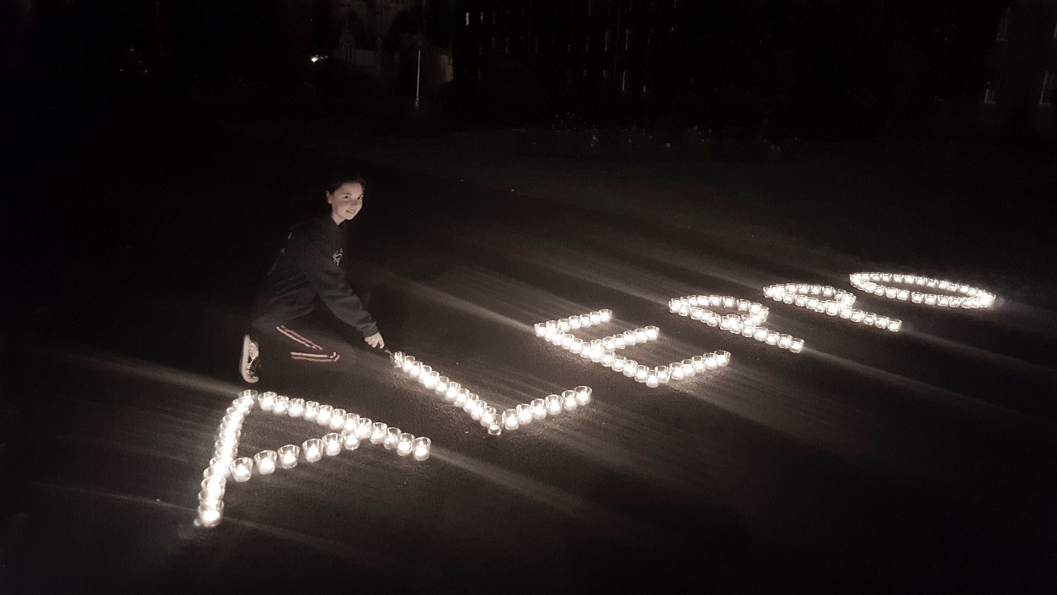

Éirn Boyce at the Trócaire vigil. Photo by Claire McEvoy
Reader 3:
"Everyone has to recognise that there is no military solution for Syria, but only a political solution. The international community must, therefore, support the peace talks heading towards the construction of a government of national unity."
Message of Pope Francis on the occasion
of the Caritas Internationalis Campaign for Peace in Syria

The Lord’s Prayer
Presider: Confident that just like in the Gospel reading where our Lord hears the cry of the blind man, God is hearing the cry of his people who are suffering through war and injustice. We unite our voices with theirs, and pray as Jesus taught his disciples for all time:
All: Our Father …
Closing prayer:
Presider: Let us pray:
"And let us consider how we may spur one another on toward love and good deeds, not giving up meeting together, as some are in the habit of doing, but encouraging one another — and all the more as you see the Day approaching."
[Hebrews 10: 24-25]

Lord our God, Father of all humanity; change the hearts of all peoples and their rulers, so that peace may be established among the nations on the foundation of justice, love and righteousness. May the Spirit of Peace descend upon the people of Syria and upon our world until all conflicts cease and peace reigns on earth. Amen.
Let us go forth and live our commitment to bring peace in the world.
Let us bless the Lord,
All: Thanks be to God!

