SHARING THE GOOD NEWS

Monthly Newsletter of the Irish Catholic Bishops’ Conference

Columba Centre, Saint Patrick’s College, Maynooth, Co Kildare

Issue 2, December 2013

Pope Francis publishes Evangelii Gaudium The Joy of the Gospel
“The joy of the Gospel fills the hearts and lives of all who encounter Jesus”, is the opening line of Evangelii Gaudium (The Joy of the Gospel), the first Apostolic Exhortation from Pope Francis. In Evangelii Gaudium the Pope invites the reader to “recover the original freshness of the Gospel”, finding “new avenues” and “new paths of creativity”. The exhortation is divided into five chapters dedicated to the Church’s missionary transformation, the crisis of communal commitment, the proclamation of the Gospel, the social dimension of evangelisation, and spirit-filled evangelisers.
Presenting the document on 26 November, Archbishop Fisichella, President of the Pontifical Council for Promoting New Evangelisation said: “If we were to sum up Pope Francis’s Evangelii Gaudium in a few words, we could say that it is an Apostolic Exhortation written around the theme of Christian joy in order that the Church may rediscover the original source of evangelization in the contemporary world. Pope Francis offers this document to the Church as a map and guide to her pastoral mission in the near future. It is an invitation to recover a prophetic and positive vision of reality without ignoring the current challenges. Pope Francis instills courage and urges us to look ahead despite the present crisis, making the cross and the resurrection of Christ once again our “victory banner”.
For the full text please scan this QR code with your smartphone or see catholicbishops.ie.
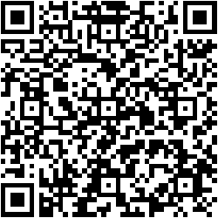
Trócaire Global Gifts 2013

This year Trócaire’s Christmas gifts include chickens, goats and school kits to help families in developing countries build a better future. Ranging from €7/£5 to €200/£170, they are on sale on the Trócaire website www.trocaire.org and by calling 1850 408 408 (RoI) or 0800 912 1200 (NI). They are also available in Veritas stores, selected Easons stores and in Trócaire centres in Maynooth, Co Kildare, Cathedral Street, Dublin, Cook Street, Cork and King Street, Belfast.

Fifty years since publication of Sacrosanctum Concilium

The National Centre for Liturgy in Maynooth has hosted a special event to celebrate the 50th anniversary of Sacrosanctum Concilium - the Constitution on the Sacred Liturgy of Vatican II. It comprised a round table discussion with Father Peter McVerry, Bishop Harold Miller and others; a public lecture by Father Jan Michael Joncas (USA) with Irish-response by Julie Kavanagh and, thirdly, a workshop on liturgical music. A report and images are available on www.liturgy-ireland.ie.
In a special video to mark its 50th anniversary, Bishop Brendan Leahy, Bishop of Limerick, offers a reflection on Sacrosanctum Concilium – why it was such a key text then and why it remains so today. This is available on the Catholic Bishops’ website - catholicbishops.ie
News SNIPPETS
- Sunday 1 December is the First Sunday of Advent. 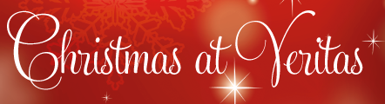
- Sunday 29 December is the Feast of the Holy Family of Jesus, Mary and Joseph. See catholicbishops.ie/family for resources.
- Catholic Schools Week will take place from 26 January - 1 February 2014 on the theme “Catholic Schools - places of faith and learning”.
- The World Day of Prayer for Peace will be celebrated on 1 January 2014.
- For all your marriage preparation needs and information on marriage counselling check out the new Accord website accord.ie.
- Bishop John Buckley, Bishop of Cork & Ross was Principal Celebrant at a Mass in Saint Finbarr’s Church, Cork on 21 November to celebrate the announcement that Nano Nagle, founder of the Presentation Sisters, has been declared venerable by Pope Francis.

Pope Francis Tweet of the Month:
The Church is missionary. Christ sends us forth to bring the joy of the Gospel to the whole world. @Pontifex

Produced by the Catholic Communications Office. For further information and contact details see www.catholicbishops.ie. Also on Facebook, Twitter, YouTube and Audioboo.
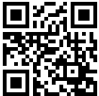

ENDS
www.veritas.ie

